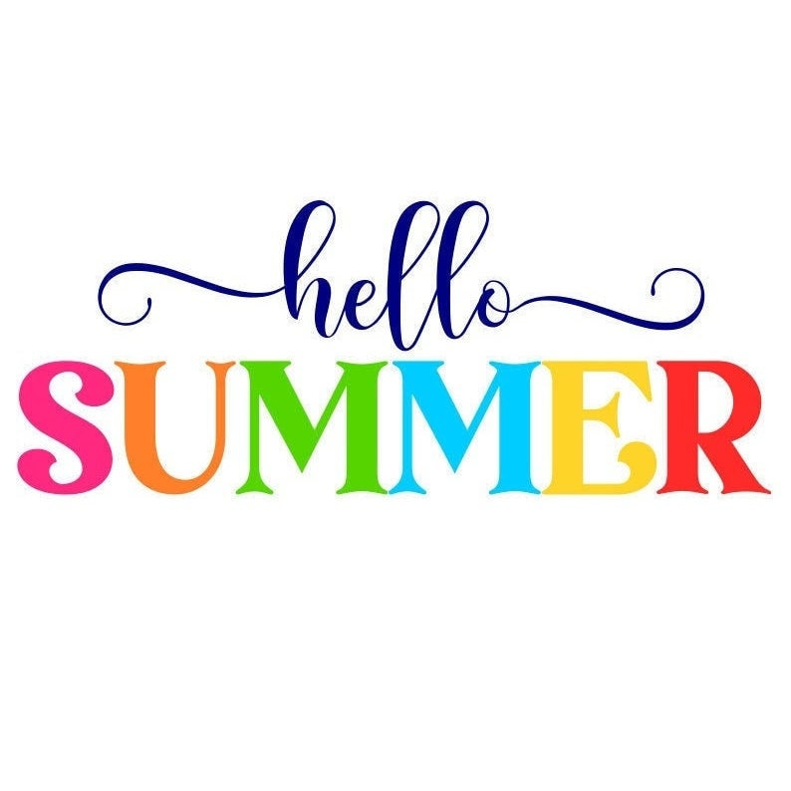

**Ms. Sweeney’s Newsletter**

MAY 12-16, 2025

Beach Week

[This Photo](https://pngimg.com/download/70894) by Unknown Author is licensed under [CC BY-NC](https://creativecommons.org/licenses/by-nc/3.0/)

**SKILLS this week**

**READING**- Beach themed fiction/non-fiction texts

**MATH**- Calendar skills and review from the year

**SOCIAL STUDIES**- Mississippi Unit



**IMPORTANT DATES**

**May 12-14-** Spring Library Book Fair

**MAY 19-** NORTHSIDE FIELD DAY

**MAY 23-** LAST DAY OF SCHOOL- **60 % DAY!**

**REMINDERS**

Please continue to send a snack and water bottle with your child daily.

